**Teleprompter**

Install nodejs from <https://nodejs.org/dist/v23.11.1/node-v23.11.1-x64.msi>

Use Casparcg server from here <https://drive.google.com/file/d/1V1LZWQmss2O4gqG5wVSHLuW2J9Y8SDoj/view?usp=drive_link>

Unzip the software with 7z <https://7-zip.org/a/7z2409-x64.exe>

Double click start Prompter.bat file from unzipped teleprompter folder

Open <http://localhost:5000> in browser

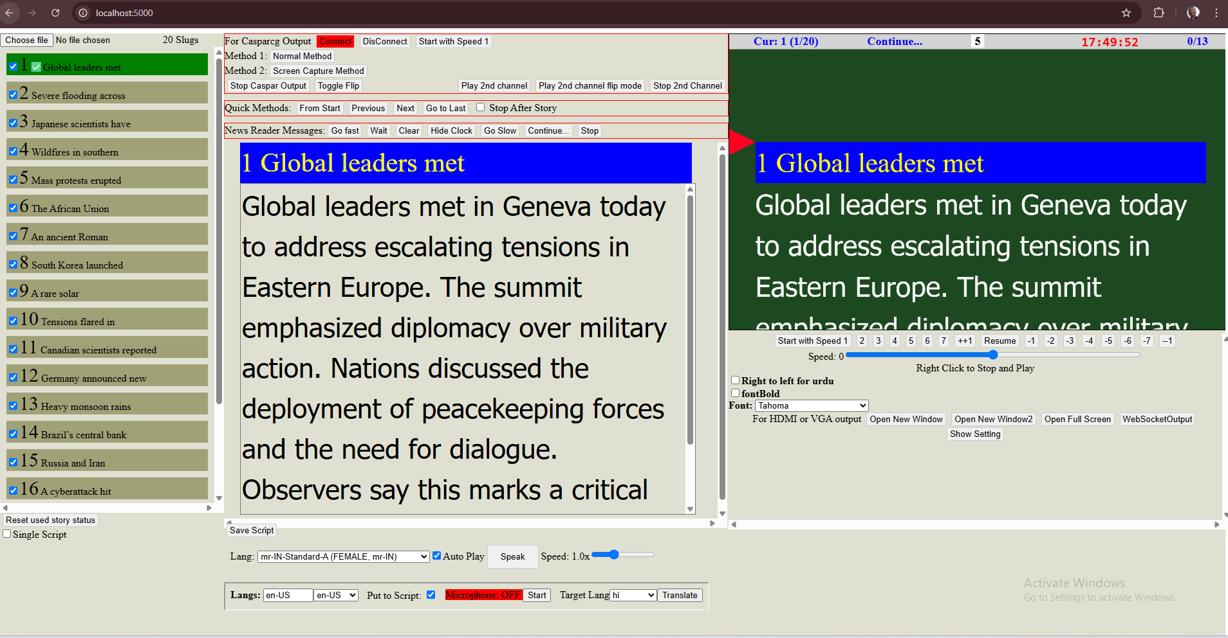

Choose a text or Docx file. Double click on required slug name, and click on required speed like 1 to start. Right click to stop and play with previous speed.

Teleprompter can be seen vertically scrolling on screen in the software itself.

1. Output can be found by clicking ‘open new window’ button. That will open a new window with teleprompter content, Then Drag it to second screen, maximize it by double clicking on title bar, then double clicking in the content. Right click to flip, again right click or double click to un-flip.

2. Casparcg output can be found by either clicking on ‘Screen Capture Method’ button or ‘Normal Method’ button. Click ‘Toggle flip’ button to flip and again click to unflip.

3. Software should be in active tab, and at least partially visible.

4. Setting of CASPAR_HOST are in .env.local file.

5. Setting of Font size and start position, bg color, font color can be done by clicking show setting button.

6. Shuttle pro setting should be imported from file in teleprompter folder ShuttleProSettingsForGoogle Chrome.pref file.

7. Mobile controller can be opened in http://[local_Ip]:5000/m

8. Slug contents can be edited and saved as new text file in download directoy.

9. Slug can be edited by speaking on microphone also, That can be translated also.